**Annual Progress Report / Final Report**

**Title**: Comparison of potato yields, soil health, and microbiome in virgin, non-virgin, and native soils

**Personnel:**

|  |  |  |  |
| --- | --- | --- | --- |
| **Name** | **Address** | **Phone number** | **Email address** |
| Timothy Paulitz | USDA-ARS | 509-335-7077 | [paulitz@wsu.edu](mailto:paulitz@wsu.edu) |
| Deirdre Griffin LaHue | Washington State University | 360-848-6127 | [d.griffin@wsu.edu](mailto:d.griffin@wsu.edu) |
| Cynthia Gleason | Washington State University | 509-335-3742 | [cynthia.gleason@wsu.edu](mailto:cynthia.gleason@wsu.edu) |
| Kenneth Frost | Oregon State University | 608-556-9637 | [kenneth.frost@oregonstate.edu](mailto:kenneth.frost@oregonstate.edu) |

**Reporting Period:** Year Initiated: 2021; Terminating Year: 2023.

**Summary of accomplishments & progress toward long-term goals:**

The goal of this project is to identify the soil physical, chemical, and biological properties associated with virgin potato fields (those being planted in potatoes for the first time), non-virgin potato fields, and native (non-cultivated) soils. To accomplish this goal, we first collected soil samples from virgin, non-virgin and native fields within the Columbia Basin and Skagit Valley in 2021 and 2022. Next, we characterized the soils and estimated the impact of each soil type on potato performance with microplot experiments. The results of the nematode communities in the soil were obtained through two techniques: sequencing-based for the 2021 samples and morphological-based for the 2022 samples. The sequencing-based method revealed a minimum of 10 distinct taxa in the 2021 samples, and up to 43 different nematode taxa in the 2022 samples. Free-living and non-parasitic nematode genera and families were most abundant in all soil types for both years. The nematode taxa's relative abundance, determined based on their feeding behavior, showed that agricultural soils were primarily dominated by bacterivores followed by fungivores, whereas native soils also showed relatively high abundance of herbivore nematodes. While the number of nematode taxa across all soil types was similar, the native soils had more nematode taxa when compared to those found in agricultural soils. Nematode community composition of non-virgin and virgin fields was indicative of disturbed, nitrogen-enriched soils with low C:N ratio and were comprised of mainly bacterivores. Overall, a less complex soil food web was observed for soil samples collected in the study. Furthermore, major soil-borne pathogens like *Fusarium* spp., *Pythium* spp., fungicide resistant strains of *Pythium* spp., *Verticillium dahliae*, and Colletotrichum coccodes were detected using soil plating methods in 2021. Interestingly, soil-borne pathogens were observed in both virgin and non-virgin fields. Moreover, there was no difference in the abundance of these organisms between virgin and non-virgin fields. Preliminary analysis of other soil physical, chemical and biological properties showed few differences between virgin and non-virgin fields, but comparatively higher disparity in native sites. The sodium absorption ratio (SAR) was significantly higher in the non-virgin soils than the virgin and native sites in the Columbia Basin, but levels were still well below the threshold for a sodic soil and this is likely not limiting yields. Variation in soil pH was observed between native and cultivated soils, with native soil in the Columbia Basin having a higher pH and in Skagit Valley, a lower pH compared to virgin and non-virgin soil. Furthermore, native sites in Skagit Valley had higher levels of soil biological properties, such as total carbon, active carbon, mineralizable carbon, and soil protein. The available water holding capacity was higher in the cultivated fields compared to native sites in the Columbia Basin, indicating that agricultural use has improved water storage potential in the area. The results of the microplot study conducted in Pullman, WA in 2021 and 2022 showed no differences in potato tuber yield and count between the virgin, non-virgin and native fields. Data on soil and potato associated bacterial, fungal, protist and nematode communities are forthcoming. After data on soil and potato associated microbiomes are obtained, a thorough data analysis will be conducted to gain more comprehensive understanding of the soil factors associated with different soil types. In the future, the results obtained from this project will contribute towards establishing soil health indicators for potato production in the Pacific Northwest region. In the long run, this research will inform future efforts to reproduce and maintain the benefits of virgin and native soils on potato yield and quality at commercial scales.

**Activities or experiments conducted:**

**Objective 1: Sample soils from virgin and non-virgin fields:**

A total of 76 soil samples were collected from major potato growing regions of Washington and Oregon during field seasons 2021 and 2022 (**Figure 1**). These samples included virgin (soil never been used for potato cultivation), non-virgin (agricultural soil with history of potato cultivation), and native (soil with no recent history of agricultural cultivation) soils. The samples were collected from both the Columbia Basin and Skagit Valley regions of Washington and Oregon (Figure 1a). To account for potential differences in soil characteristics, soil samples were collected in pairs or triplets for each field. This means that for each virgin field, soil from nearby non-virgin and native fields were also obtained. For each sample, soils were collected from three spots in the field following a zigzag pattern, at a soil depth of up to eight inches. The crop history and vegetation type were recorded during sampling or requested from growers or will be retrieved from a crop data layer developed by the USDA if not available otherwise. The soil samples were brought to a common location, mixed thoroughly, and used for soil characterization and microplot studies. The soils were stored at -20°C for microbiome studies.

**Objective 2: Characterize soil physical, chemical, and biological properties:**

Soil bacterial, fungal, and protist community: The soil samples were retrieved from the freezer and ~0.25 gram of soil was used for DNA extraction. DNeasy PowerSoil kit (Qiagen, Carlsbad, CA) was used for the DNA isolation in accordance with the manufacturer’s protocol. The DNA was quantified using a Nanodrop spectrophotometer (Thermo Fisher Scientific, Waltham, MA) and then will be sent to the University of Minnesota Genomics Center (UMGC) for library preparation and sequencing. For bacterial genome, V3-V4 region of the 16S rRNA gene will be amplified using a dual-indexing approach with primers 357wF: 5ʹ-CCTACGGGNGGCWGCAG-3ʹand 785R: 5ʹ-GACTACHVGGGTWTCTAAT-3ʹ. Similarly, for the fungal community, the Internal Transcribed Spacer (ITS) region will be amplified using primers ITS1F (5′- CTTGGTCATTTAGAGGAAG*TAA −3′) and ITS2 (5′- GCTGCGTTCTTCATCGA*TGC-3′) Additionally, for protist community 1380F (5′-CCCTGCCHTTTGTACACAC-3′), and 1510R (5′-CCTTCYGCAGGTTCACCTAC-3′) primer will be used to amplify 18s rRNA gene region. The amplicons will be further indexed, pooled, and sequencing will be performed on the Illumina MiSeq platform.

Soil nematode community: A soil sub-sample of nearly 100 grams was taken from the composite sample for nematode extraction. Prior to taking the sub-sample, any visible crop residues, stones and clumps were removed. The nematodes were extracted using a combination of sieving and decanting and sugar floatation techniques and nematodes and were collected in 15 ml suspension tube. DNA extraction was completed using DNeasy Powerlyzer PowerSoil kit (Qiagen, CA) following the provided protocol and was sent to UMGC for nematode community sequencing. 18S rDNA region will be amplified using the primers, NF‐1 (GGTGGTGCAT GGCCGTTCTTAGTT) and 18Sr2b (TACAAAGGGCAG GGACGTAAT). In addition to amplicon sequencing, morphology-based nematode identification and quantification will be done. For this purpose, a separate nematode extraction will be performed using the procedure described earlier. Nematodes will be identified and counted at genus level under a microscope at 100X magnification. The sequence data for 2021 samples and morphology based nematode community counting for 2022 samples has been completed and the DNA for 2022 is ready to be sent for sequencing as described earlier.

Soil-borne pathogen abundance: The presence and abundance of major soil-borne pathogens of potato were determined with a culture-dependent method. Several putative soil-borne pathogens including *Fusarium* spp., *Pythium* spp., fungicide-resistant strains of *Pythium* spp., *Verticillium dahliae*, and *Colletotrichum coccodes* were cultured in Petri dishes and quantified. Propagule numbers were averaged across four replications for *Fusarium* spp., *Pythium* spp., *Verticillium dahliae* and *Colletotrichum coccodes*. Obtained propagule count data were converted to the number of propagules per gram of soil for each pathogen and will be used for further inference. The data for 2021 samples have been obtained and processing of 2022 samples is in progress.

Soil physical, chemical and biological properties: The soil's physical, chemical, and biological properties were assessed using the Tier 1 indicators from the Soil Health Institute and the Comprehensive Assessment of Soil Health (Moebius-Clune et al. 2017; Norris et al. 2020). The soil samples were analyzed for various physical properties including texture and plant-available water holding capacity, chemical properties like pH, electrical conductivity, nutrient levels (P, K, Ca, Mg, Na), cation exchange capacity, and sodium adsorption ratio, and soil biological properties such as total carbon (C) and nitrogen, mineralizable C (respiration), active carbon (permanganate oxidizable C; POXC), C-cycling enzymes, and soil protein levels. Soil analysis has been obtained most of the properties for 2021 and 2022 samples, and we are in the process of analyzing the results.

**Objective 3: Quantify potato performance in microplots:**

Potato disease expression and yields in soils collected from virgin, non-virgin and native fields were quantified in a microplot study. Microplots were established in Pullman, WA (**Figure 2**). The study had a two-way design with soil factors (virgin, non-virgin, and native) nested within location factors (Skagit Valley and Columbia Basin). The pots were arranged in a randomized complete block design along the predominant environmental gradient at the site. Each pair/triplet of fields were assigned randomly to the block. For the 2021 field season, the study only included soil samples from virgin and non-virgin fields. However, in 2022, an additional soil type, native soil, were also included in the study. Pots were filled with soil and Russet Burbank potatoes were planted in each pot during first week of May. Before planting, seed tubers were assayed on semi-selective media for the presence of the *V. dahliae and C. coccodes*. Seed tubers free of *V. dahliae* and *C. coccodes* were used for planting. Plants were watered regularly, and plots were weeded as needed. Pots were harvested in mid-October or upon plant senescence. Potato tuber weight and tuber count were recorded for each microplot.

**Objective 4: Study of potato associated microbiome:**

Samples from potato rhizosphere, endosphere and bulk soil were collected from the microplots two months after planting to characterize the soil bacterial, fungal and protist community associated with potatoes for field season 2022. Briefly, soil samples were collected from the potato rhizosphere using a six inche deep soil probe. All roots were separated out from the bulk soil and shaken to remove the adhered soil. The roots were placed in 15 ml tubes and 3 ml distilled water was added to the tube followed by sonication for 2 minutes to dislodge surface attached microbial communities into the soil slurry. Roots were removed from the tube and washed in running water and were used for the endospheric community characterization. The soil slurries represented the rhizosphere sample. 1 ml of slurries was used for the DNA extraction. Further, a thin slice of tuber skin was taken from three tubers immediately after potato harvesting to study the microbial communities in the tuber skin. All bulk, rhizosphere, endosphere and tuber samples were stored in –20°C freezer until processing. DNA extraction was completed using DNeasy PowerSoil Kit with slight modification for rhizosphere and bulk soil samples and with DNeasy PlantMini Kit for roots and tuber samples. The samples will then be sent to UMGC for bacterial, fungal and protist community sequencing as described above. From this part we will have good understanding of what type of microbiomes and how differently microbiomes are recruited by the potato plant when grown in soil with various cropping histories.

**Objective 5: Data visualization and statistical analysis:**

Visualization techniques, such as boxplots, scatterplots, non-metric multidimensional scaling (NMDS), principal components analysis (PCA) were used to explore the relationships between soil characteristics and potato yields. In order to understand nematode community diversity, both alpha and beta diversity indices were calculated. For alpha diversity, Shannon’s diversity index was calculated, and a statistical test was conducted using a linear mixed model with the "lme4" package in R, with field type (virgin, non-virgin, native) as a fixed effect and location as a random effect. The beta diversity was also computed, which measures the distance between the samples. Due to the high dimensionality of the obtained beta diversity, non-metric multidimensional scaling (NMDS) was used to reduce it to a lower dimension. The two resulting features were visualized using a biplot. A permutational multivariate analysis of variance (PERMANOVA) was performed for the statistical analysis of beta diversity using the "adonis" function in the "vegan" package in R. The dispersion effect was also estimated. Furthermore, nematode-based soil health indicators, including the enrichment index, structure index, and maturity index, were calculated for all samples. The correlation coefficients were calculated between soil health indicators and soil characteristics (physical and chemical) and the relationship among variables were visualized using heat map. Further, soil properties, potato yield and count data were analyzed considering field type as a fixed effect and location as a random effect. We will complete comprehensive analysis once we obtain sequence data for microbiome.

**Results and Discussion:**

The results for the soil nematode communities have been obtained for sequencing-based technique for 2021 samples and morphological-based method for 2022 samples. For 2021 samples, obtained sequences were classified to eight genera, one family and one at order level. There was a lot of nematode diversity between samples in the virgin and non-virgin sites. Many of the identified genera contained free-living nematodes. *Ditylenchus*, a genus of plant parasitic nematodes, was found in both virgin and non-virgin soil samples (**Figure 3A**). Further, statistical analysis on diversity and correlation with soil factors will be performed to better understand the soil nematode communities in both soil types.

In 2022 samples, a total of 43 different nematode taxa were identified using a morphology-based method (**Figure 3B)**, with the majority being classified at the genus level. The majority of these taxa were free-living and non-parasitic nematodes. In a few samples, plant-parasitic genera such as *Pratylenchus*, *Meloidogyne*, *Paratrichodorus*, and *Ditylenchus* were recovered. However, the abundance of potato parasitic nematodes was low compared to the rest of the taxa and were also recovered in native soils. The Rhabditida order, which primarily consists of bacterivores, was the most abundant in all soil types and both locations. *Cruznema*, a bacterivore nematode genus that plays a role in nitrogen mineralization by releasing excess nitrogen, was more abundant in non-virgin soils of the Columbia Basin and less frequent or absent in the other soil types (Ferris et al. 1997). *Acrobeles*, a common bacterivore in agricultural soil, was abundant in the Columbia Basin but was less abundant in Skagit Valley soils. *Criconema*, a genus that feeds on root tips and mature roots (Cordero et al. 2012), and the Tylenchidae family, mostly consisting of fungal and algal feeders, were almost exclusively associated with native soils from the Skagit Valley (Qing and Bert 2019). This is not surprising as the native soils from Skagit Valley included samples from perennial forests. **Figure 3C** shows the relative abundance of nematode taxa based on their feeding habits. Non-virgin soils were dominated by bacterivores, followed by fungivores, in both the Columbia Basin and Skagit Valley. In addition to bacterivores and fungivores, native soils in both regions had a relatively high abundance of herbivores. Although predators had relatively low abundance overall, they were absent in non-virgin soils in the Columbia Basin.

Based on the taxa count data for nematode community, diversity indices were calculated. Shannon's diversity index, which estimates the within-sample diversity (alpha diversity), was calculated for each sample (**Figure 4A**). There was no statistically significant difference (*P* < 0.05) in the Shannon's diversity index between soil types. The beta diversity which measures the diversity between samples was also calculated. According to the biplot, no unique clusters were obtained for the soil types (**Figure 4B**). Although there was not statistically significant (*P* <0.05) location effect, a statistically significant (*P* < 0.05) dispersion effect was observed for the native soil. The native soil samples had high variance and were more dispersed from the centroid compared to the virgin and non-virgin soils. The virgin and non-virgin soils had similar nematode community compositions. Previous studies have reported high species diversity within agricultural soil samples, meaning high alpha diversity and similar beta diversity across the samples. The same pattern was observed in the soil nematode communities in our study, with native soils being more dispersed than the non-virgin and virgin soils.

Nematodes are important part of the below ground soil web. Their occurrence in wide range of habitats and feeding behaviors make them valuable biological indicators for assessing soil health. Several nematode based soil health indicators have been developed to assess the health of soil (Ferris and Bongers 2009, Preez et al. 2022). The Enrichment Index, which informs about food availability and nutrient enrichment in soil, and the Structure Index, which indicates the complexity of soil food web structures, were calculated. The native soils had a higher Structure Index, while majority of non-virgin and virgin soils had a higher Enrichment Index. The Structure Index was plotted against the Enrichment Index in **Figure 4C** and the interpretation of the plot is shown in Figure **4D**. According to the plot, only two samples belonged to the upper right quadrant representing maturing, nitrogen-enriched, low C:N ratio, bacterial soil and one sample in the lower right quadrant (matured, fertile, moderate C:N ratio soil), and all three samples were from native fields (Preez et al. 2022). The majority of soils from non-virgin and virgin fields belonged to the upper left quadrant, meaning they are disturbed, nitrogen-enriched soils with low C:N ratio and mostly dominated by bacterivores. Additionally, the Maturity Index that indicates environmental disturbance was calculated. A high value of the Maturity Index represents a complex soil food web (Preez et al. 2022). All samples had values less than 2.5, indicating high disturbance and less complex food web structures present in Pacific Northwest soils based on the nematode community analysis (**Figure 4E**). Overall, many of the native sites tended to be more structured, with higher trophic levels like predators and omnivores. Most of the cropped locations were higher in bacterivores, indicating higher levels of N and N cycling. Many of the native sites had a dominance of fungal feeders, indicating higher C/N ratios and more depleted N. This type of analysis is an important indication of N cycling, especially from organic N sources that are mineralized by microbes and then more N released from nematode feeding. The correlation between nematode-based soil health indicators and soil characteristics was also computed. Active carbon and protein content had a positive relationship with the Structure Index, while the opposite relationship was observed for the Enrichment Index (**Figure 4F**). Bacterivore nematodes were positively correlated with sandy soil and electrical conductivity, while negatively associated with soil pH, silty soil, and calcium content. Fungivore nematodes were positively correlated with soil pH, potassium, and calcium content (**Figure 4F**).

Soil-borne pathogen propagules were detected in both virgin and non-virgin fields in 2021 samples (**Figure 5**). The most abundant and potentially plant pathogenic fungi detected were *Fusarium* spp. had followed by *Pythium* spp. (**Figure 5A, 5C**). Fungicide resistant *Pythium* spp. were also detected in both virgin and non-virgin fields. *V. dahliae* was observed in soil collected from three virgin and four non-virgin fields, whereas *C. coccodes* was observed in just one virgin field and no non-virgin fields. There was no significant difference (*P* < 0.05) in *Fusarium*, *Pythium*, *V. dahlia*e, and *C. coccodes* populations between virgin and non-virgin soil (**Figure 5**). The relatively high abundance of both *Fusarium* and *Pythium* in both virgin and non-virgin fields supports the hypothesis that the hosts/substrates supporting these pathogens were present in both types of fields. However, further characterization is needed to determine if the *Fusarium* spp. observed in this study are pathogenic towards potatoes.

Preliminary analysis shows few significant differences between virgin and non-virgin fields for most soil biological, physical, and chemical soil properties (**Figure 6**). An exception is the sodium absorption ratio (SAR; **Figure 6H**), which was significantly higher in non-virgin fields than virgin and native sites in the Columbia Basin. However, the median SAR in the non-virgin sites was 0.2, which is well below the cut-off of 13 that defines a sodic soil and thus is likely not limiting yields. Many of the parameters showed that the cultivated sites differed from the native sites, particularly in Skagit Valley where soil biological measurements (total C, active C, mineralizable C, soil protein) were all greater in the native site. The native sites in Skagit were treed areas adjacent to cultivated fields on similar soil types, so it is to be expected that soil C levels would be significantly higher due to plant inputs. Also of note was a change in soil pH between cultivated and native sites in both locations. Native soil pH was higher than cultivated fields in the Columbia Basin, likely due to less fertilizer-induced pH change (nitrification), and native pH was lower than cultivated soil pH in Skagit Valley, likely due to the addition of lime to cultivated soils. Available water holding capacity was also greater in cultivated fields compared to native sites in the Columbia Basin, indicating that agricultural use has increased water storage potential in the region.

The current dataset shows that there are no soil parameters that appear to be limiting yields in non-virgin fields; however additional relationships may be elucidated with the addition of the soil microbiome data.

Potato yield and count data for 2021 (**Figure 7A**) and 2022 (**Figure 7B**) were visualized using boxplots. The median values for both yield and count data were similar across soil types in the soil collected from the Columbia Basin. For 2022, native soils from the Skagit Valley showed relatively lower potato yields. This might be due to the late planting of the native soils compared to the rest of the plots. Statistical analysis showed no significant differences in potato yield and tuber number between the virgin, non-virgin, and native fields in both 2021 and 2022 **(Figure 7**). The yield benefits observed in the virgin soils by the growers were observed in the microplot study, which could be due to the fact that the yield data are collected at the population scale, whereas the study only included a single potato plant.

Once we obtain data on soil and potato associated microbiome we will complete a complete data analysis to gain more comprehensive understanding of the soil factors associated with different soil types.

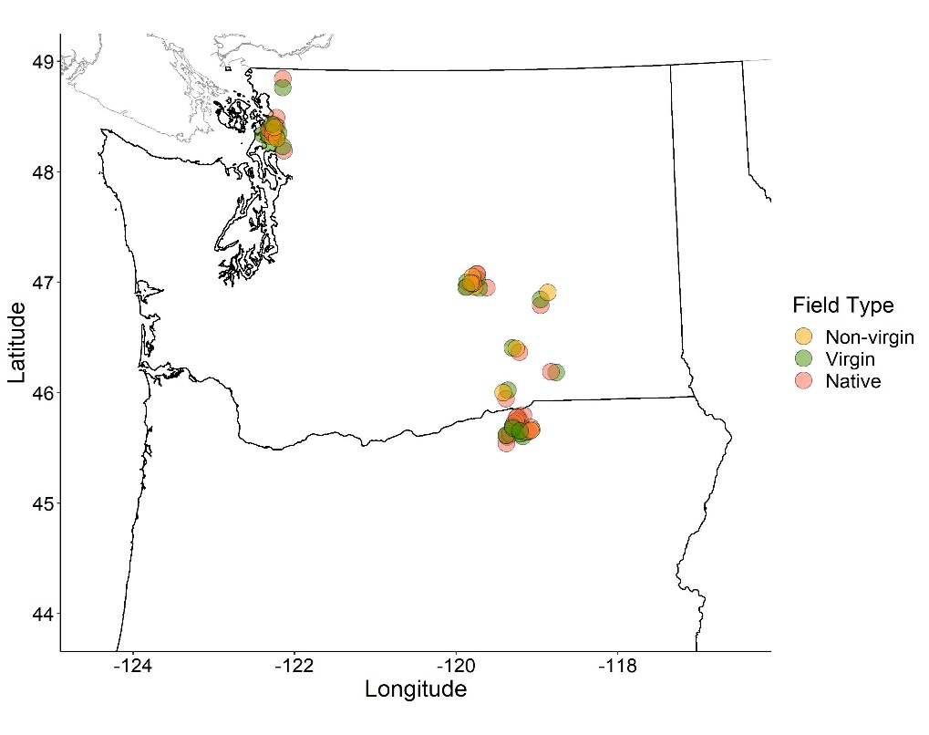

**Figure 1.** Soil sampling locations in WA and OR in 2021 and 2022. The color indicates the soil types. A total of 76 soil samples including 22 from 2021 and 54 from 2022 growing season were obtained for the study.

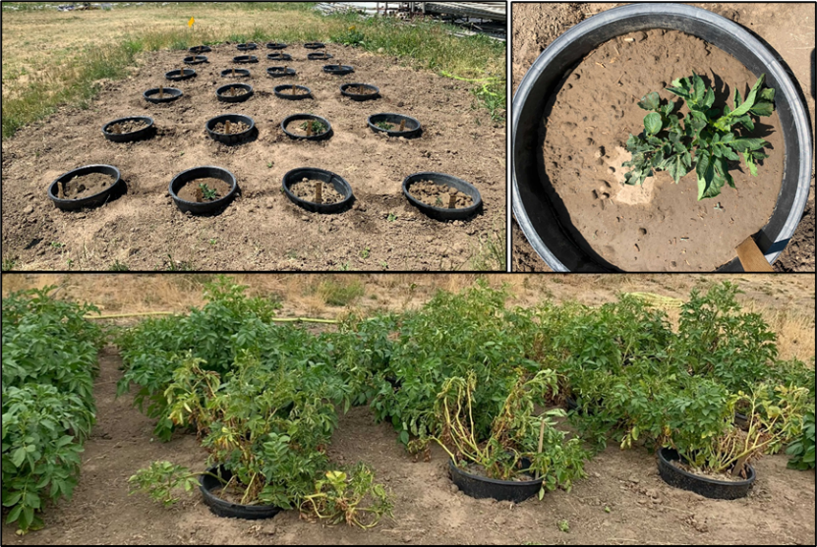

**Figure 2.** Microplots in Pullman, WA.

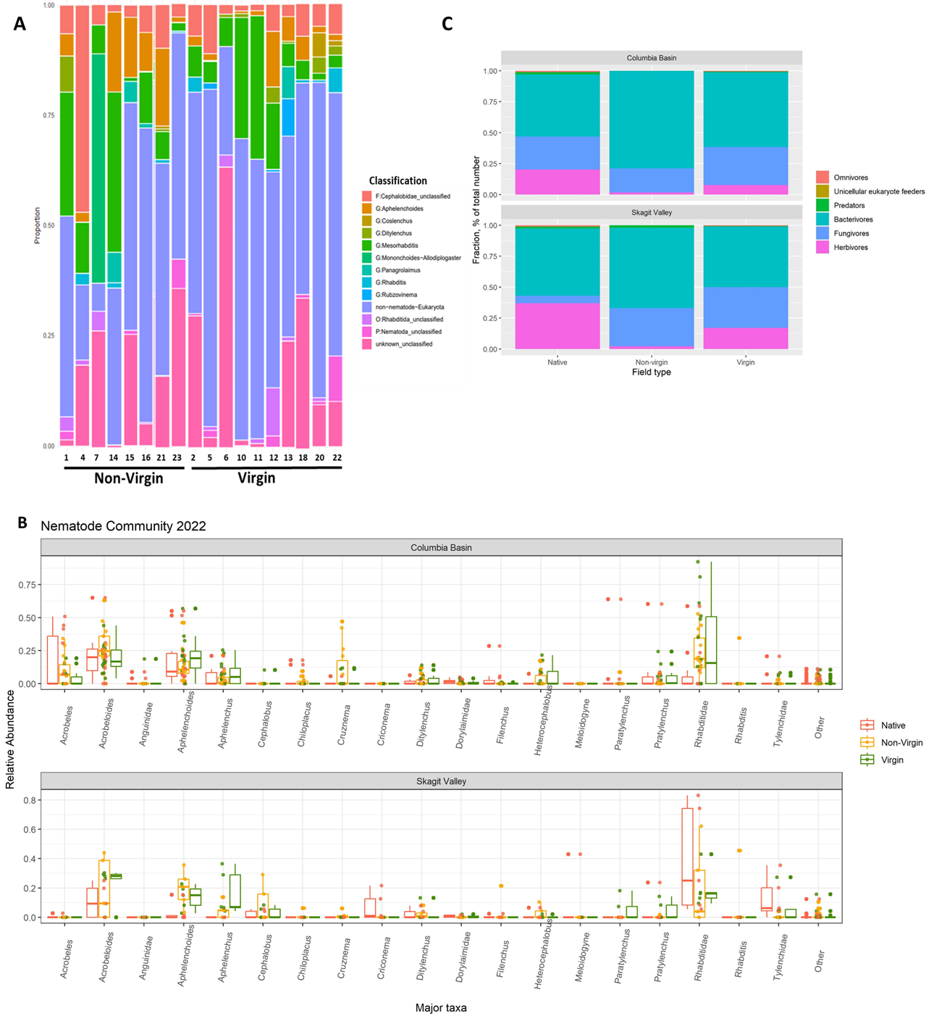

**Figure 3. (A)** Classification of nematodes to the taxonomic level of phylum (P), order (O), family (F), or genus (G) in non-virgin and virgin fields for 2021 samples using amplicon sequencing based approach. The x-axis represents the soil samples and y-axis shows the relative proportion of the specific taxa. **(B)**. Taxa (genus, order, family) level identification and quantification of major groups of nematodes using a morphology-based method for 2022 samples. The nematode taxa are plotted against the relative abundance and color represents the soil type. **(C)** Relative abundance of nematodes based on feeding habits in 2022 soil samples.

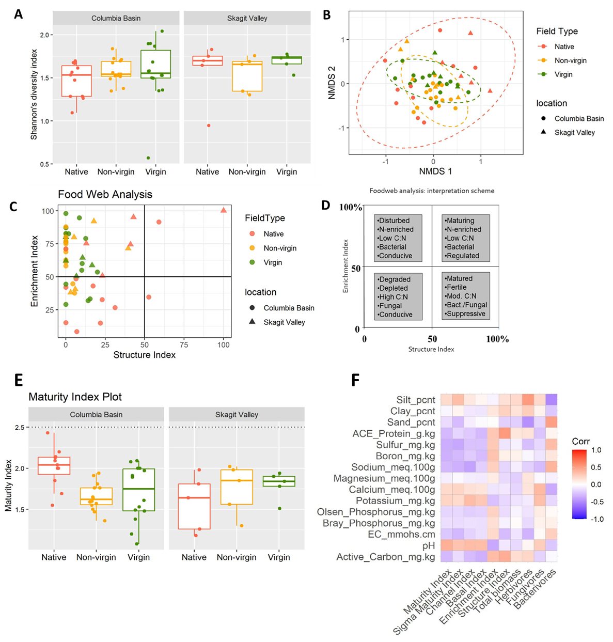

**Figure 4.** Nematode community-based diversity and soil health indices for 2022 samples. (**A**) Box plot showing alpha diversity value for soil samples. The color represents the soil types and y-axis represents the Shannon’s diversity index value. (**B**) Beta diversity values visualized using biplot using the newly projected dimensions calculated using NMDS. The color indicates soil type while the shape of the points represents the location. (**C**) Plot showing the complexity of soil food web by plotting Structure Index on the x-axis and the Enrichment Index on the y-axis. Color and shape of the points represent the soil type and location respectively. (**D**) Food web analysis interpretation guide plot. (**E**) Boxplot displaying the soil Maturity Index values for all three soil types as indicated by color. (**F**) Heat map showing the correlation between various nematode-based soil health indicators and soil characteristics, where red represents a positive relationship and blue represents a negative association.

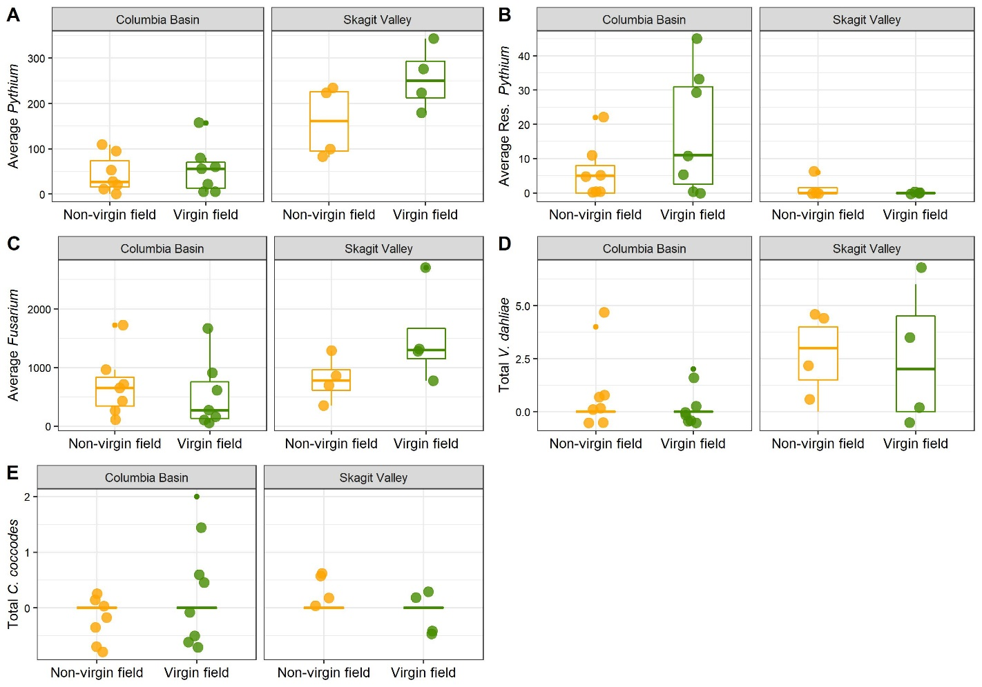

**Figure 5.** Abundance of soil-borne pathogens including (**A**) *Pythium* spp., (**B**) fungicide-resistant *Pythium* spp., (**C**) *Fusarium* spp., (**D**) *Verticillium dahliae*, and (**E**) *Colletotrichum coccodes* in the soil collected from virgin and non-virgin fields in 2021. Average propagules per gram of soil were recorded for *Fusarium* spp. and *Pythium* spp., whereas a total number of propagules per gram of soil was recorded for the *V. dahliae* and *C. coccodes*

**Figure 6.** Soil biological (A-E), chemical (F-J), and physical (K and L) properties for native, non-virgin, and virgin sites sampled in 2021 and 2022.

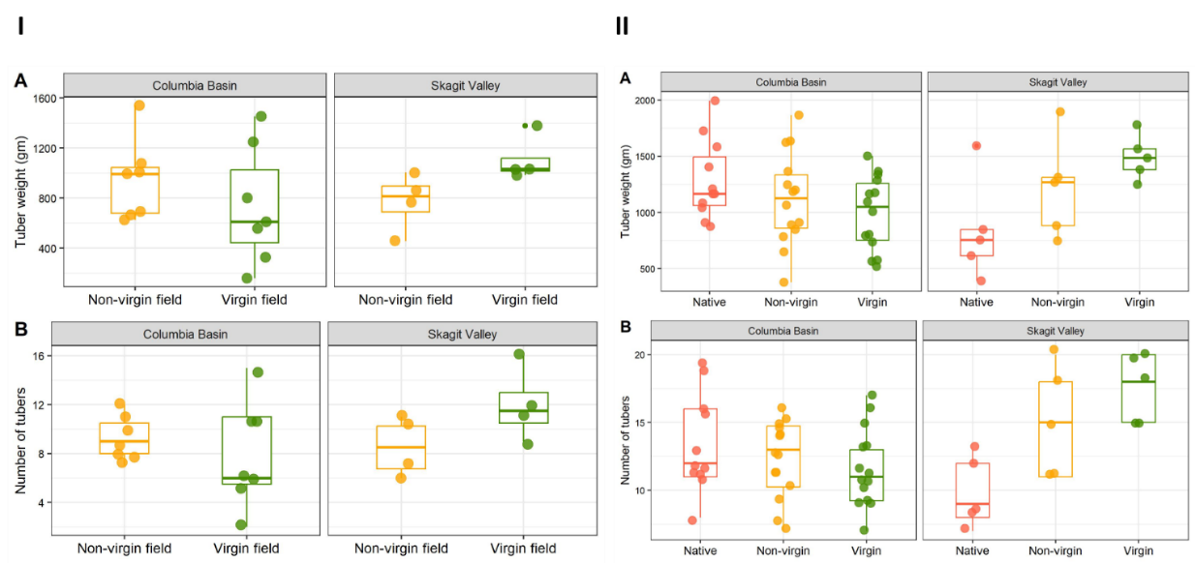

**Figure 7.** Potato performance in microplots for (**I**) 2021 and (**II**) 2022 field season. (**A**)Total tuber weight (grams), and (**B**) the total number of potato tubers recovered from plants grown in virgin, non-virgin and native soils in 2021 and 2022.

**Publications: NA**

**Presentations & Reports: NA**

**References:**

Cordero, M.A., Robbins, R.T. and Szalanski, A.L., 2012. Taxonomic and molecular identification of *Bakernema, Criconema, Hemicriconemoides, Ogma and Xenocriconemella* species (Nematoda: Criconematidae). *Journal of Nematology*, *44*(4), p.427.

Du Preez, G., Daneel, M., De Goede, R., Du Toit, M.J., Ferris, H., Fourie, H., Geisen, S., Kakouli-Duarte, T., Korthals, G., Sánchez-Moreno, S. and Schmidt, J.H., 2022. Nematode-based indices in soil ecology: Application, utility, and future directions. *Soil Biology and Biochemistry*, *169*, p.108640.

Ferris, H., Venette, R.C. and Lau, S.S., 1997. Population energetics of bacterial-feeding nematodes: carbon and nitrogen budgets. *Soil Biology and Biochemistry*, *29*(8), pp.1183-1194.

Ferris, H.O.W.A.R.D. and Bongers, T., 2009. Indices developed specifically for analysis of nematode assemblages. In *Nematodes as environmental indicators* (pp. 124-145). Wallingford UK: CABI.

Golhasan, B., Heydari, R., Esmaeili, M. and Miraeiz, E., 2017. Description of *Aphelenchoides macrospica* n. sp.(Nematoda: Aphelenchoididae) from northwestern Iran. *Journal of Nematology*, *49*(1), pp.67-76.

Kabir, Z., Bhat, R.G. and Subbarao, K., 2004. Comparison of media for recovery of *Verticillium dahliae* from soil. *Plant disease*, *88*(1), pp.49-55.

Qing, X. and Bert, W., 2019. Family Tylenchidae (Nematoda): an overview and perspectives. *Organisms Diversity & Evolution*, *19*(3), pp.391-408.